Chapter 14, Problem 90.

Obtain the frequency response of the circuit in Fig. 14.40 (see Practice Problem 14.10). Take R₁ = R₂ = 100 Ω, L = 2 mH. Use 1 < f < 100,000 Hz.

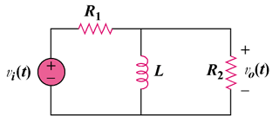

Figure 14.40
For Prob. 14.90.

